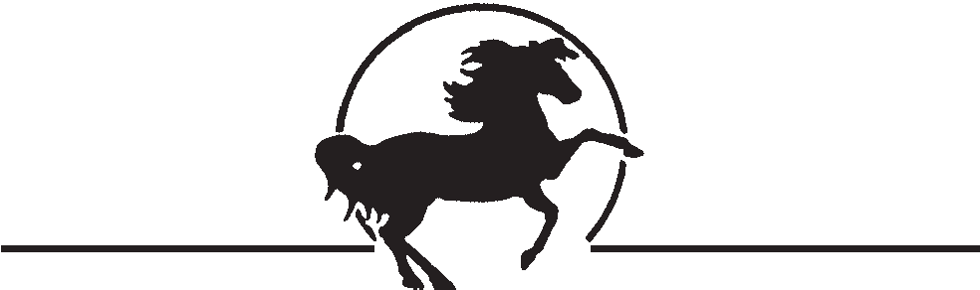
SUNDANCE FARM
N6329 Branch Rd. • Plymouth, WI 53073 • (920) 893-0134
SUNDANCE FARM LIABILITY RELEASE FORM
THIS LIABILITY RELEASE AND EXPRESS ASSUMPTION OF RISK is made and entered into on this ___day of __________________, 20__, by and between Kelly Mahloch, Sundance Farm, and Sundance Farm of Plymouth, LLC, hereinafter designated Equine Professional and ______________________, hereinafter designated Participant: and , if Participant is a minor, Participant’s parent or guardian, _______________________. In return for the use today, and all future days, of property, facilities, and services of the Equine Professional, the Participant, his heirs, assigns and legal representatives, hereby expressly agree to the following:
- Participant is responsible for full and complete insurance coverage on his horse personal property and himself.
- Participant understands there are INHERENT RISKS in and around equine activities.
These are dangers or conditions that are and integral part of equine activities, including but not limited to: the propensity of an equine to behave in ways the may result in injury or harm or the death of persons around the equine: including bucking, biting, kicking, rearing, shying, falling, or stepping on; the unpredictability of an equine’s reaction t such things as medications, sounds, sudden movements, unfamiliar objects, persons or other animals; hazards such as surface and subsurface ground conditions, collisions with other equines or objects; or the potential of another participant to not maintain control over the equine or to not act within the person’s ability, and /or act in a negligent manner.
- PARTICIPANT EXPRESSLY ASSUMES RESPONSIBILITY FOR ALL RISKS INVOLVED IN OR ARISING FROM PARTICIPANT’S USE OF OR PRESENCE UPON EQUINE PROFESSIONAL’S PROPERY OR FACILITIES including, without limitation but not limited to: the risks of death, bodily injury, property damage, falls, kicks, bites, collisions with vehicles, horses or stationary objects, fire or explosion, the unavailability of emergency medical care, and/or the negligence and/or deliberate act of another person.
- Participant agrees to hold Equine Professional and all successors, assigns, subsidiaries, franchisees, affiliates, officers, directors, employees and agents completely harmless and not liable and releases them from all liability whatsoever and AGREES NOT TO SUE them on account of or in connection with any claims, causes of action, injuries, damages, costs or expenses arising out of Participant’s use of or presence upon Equine Professional’s property and facilities, including without limitation, those based on death, bodily injury, property damage, including consequential damages, except if the damages are caused by the direct, willful and wanton gross negligence of the Equine Professional.
- Participant agrees to waive the protection afforded by any statute or law in any jurisdiction whose purpose, substance and/or effect is to provide that a general release shall not extend to claims, materials or otherwise, which the person giving the release does not know or suspect to exist at the time of executing the release.
- Participant agrees to indemnify and defend Equine Professional against, and hold harmless from any and all claims, causes of action, damages, judgments, costs or expenses, including attorneys’ fees, which in any way arises from Participant’s use of or presence upon the Equine Professional’s property and facilities.
- Participant agrees to abide by all of Equine Professional’s rules and regulations, and Participant is responsible for using protective gear; i.e. hard hat and boots.
- This contract is non-assignable and non-transferable and is made and entered into in the State of Wisconsin, and shall be enforced and interpreted under the laws of this state. Should any clause be in conflict with State Law, then that clause is null and void.
- WARNING: UNDER WISCONSIN LAW, AN EQUINE ACTIVITY SPONSOR OR EQUINE PROFESSIONAL IS NOT LIABLE FOR INJURY TO, OR THE DEATH OF, A PARTICPANT IN EQUINE ACTIVITIES RESULTING FROM THE INHERENT RISKS OF EQUINE ACTIVITIES
(WISCONSIN STAT 895.525)
When the Equine Professional and Participant (and Participant’s parent or guardian) sign this contract, it will then be binding. I HAVE READ AND UNDERSTAND THIS RELEASE.

________________________________________
Kelly Mahloch

_________________________________________
Participant or Participant’s Guardian Signature

___________________________________________ ________________________
Participant’s Address Participant’s phone number

________________________________________________
Participant’s E-mail address

